Abstract
The project entitled as ” Brain Tumor Detection With Severe Identification Using K-Means Clustering” The detection and quantification of tumors in brain MRI images are crucial tasks in the field of medical imaging, aiding in diagnosis and treatment planning. In this project, we propose a method utilizing k-means clustering for the detection and quantification of brain tumors. The primary objective is to accurately identify the presence of tumors within MRI scans and to estimate the percentage level of tumor involvement in the brain.
The proposed approach begins by preprocessing the MRI images to enhance contrast and reduce noise, thereby improving the effectiveness of subsequent analysis. Subsequently, k-means clustering is applied to segment the MRI images into distinct clusters, with each cluster representing different tissue types within the brain. By exploiting the inherent intensity differences between healthy tissue and tumor regions, the clusters corresponding to tumor tissue can be identified.
Following the segmentation step, post-processing techniques are employed to refine the segmentation results and extract meaningful features indicative of tumor presence and extent. These features include the size, shape, and spatial distribution of tumor regions within the MRI scans. Through quantitative analysis of these features, the percentage level of tumor involvement in the brain can be estimated, providing valuable information for medical professionals.
The effectiveness of the proposed method is evaluated using a dataset of brain MRI images containing both tumor and healthy cases. Performance metrics such as sensitivity, specificity, and accuracy are computed to assess the reliability and accuracy of tumor detection. Additionally, the estimated percentage level of tumor involvement is compared against ground truth annotations provided by medical experts to validate the quantitative analysis.Overall, the proposed approach demonstrates promising results in the detection and quantification of brain tumors using k-means clustering. By providing accurate assessments of tumor presence and percentage involvement, the proposed method has the potential to assist clinicians in making informed decisions regarding patient diagnosis and treatment planning, ultimately improving patient outcomes and quality of care.
INTRODUCTION

The detection and early diagnosis of brain tumors represent critical steps in improving patient outcomes and guiding effective treatment strategies. With advancements in medical imaging and computer vision technologies, there is a growing need for automated systems that can streamline the analysis of complex medical images, such as brain scans. The project titled "Brain Tumor Detection with Severity Identification Using K-Means Clustering" addresses this imperative by presenting an innovative application that combines computer vision and image processing techniques. This system offers a comprehensive approach to tumor identification, leveraging OpenCV for color space conversion and thresholding to isolate potential tumor regions, contour detection for precise delineation, and percentage calculation to quantitatively assess the extent of tumor presence.

A pivotal aspect of the project lies in its utilization of K-Means clustering, contributing to the identification and severity assessment of brain tumors. By integrating K-Means clustering into the image processing pipeline, the system enhances its ability to categorize tumor regions based on characteristics such as size, shape, and intensity. This not only aids in the discrimination between malignant and benign tumors but also lays the groundwork for more nuanced severity classification. The inclusion of K-Means clustering aligns with the broader trend in leveraging machine learning techniques to augment the capabilities of medical image analysis systems, fostering a more sophisticated and data-driven approach to tumor detection.
Furthermore, the project incorporates a user-friendly Graphical User Interface (GUI) built with Tkinter, allowing healthcare professionals to input patient details, visualize original and processed images, and trigger the tumor identification process seamlessly. This user-centric approach facilitates the integration of the system into clinical workflows, empowering medical practitioners with an efficient and accessible tool for early tumor detection and diagnosis. As medical imaging and computational methodologies continue to evolve, this project stands at the intersection of technological innovation and healthcare, contributing to advancements that hold the potential to transform the landscape of neuroimaging and patient care.

Brain tumors pose a significant health concern worldwide, with their timely detection and accurate characterization crucial for effective treatment planning and patient management. Magnetic Resonance Imaging (MRI) has emerged as a powerful tool in the diagnosis of brain tumors, offering high-resolution images that can reveal detailed anatomical structures and pathological abnormalities. However, the manual interpretation of MRI scans by radiologists is time-consuming and subject to inter-observer variability. As a result, there is a growing need for automated image analysis techniques to assist clinicians in the reliable detection and quantification of brain tumors.

In this context, machine learning algorithms, particularly clustering techniques such as k-means, have shown promise in segmenting medical images and identifying regions of interest corresponding to pathological conditions. By leveraging the inherent intensity variations in MRI scans, k-means clustering can partition the image into distinct clusters, facilitating the differentiation of healthy tissue from abnormal regions, such as tumors. In this project, we propose a novel approach that utilizes k-means clustering for the automated detection of brain tumors in MRI images and the estimation of the percentage level of tumor involvement. This introduction sets the stage for the subsequent sections, which will delve into the methodology, experimental evaluation, and potential clinical implications of our proposed approach.

Objectives
- Develop a robust algorithm utilizing k-means clustering for automated detection of brain tumors in MRI images.
- Implement preprocessing techniques to enhance image quality and reduce noise, thereby improving the accuracy of tumor segmentation.
- Utilize post-processing methods to refine segmentation results and extract relevant features for quantitative analysis.
- Quantify the percentage level of tumor involvement in the brain by analyzing the size, shape, and spatial distribution of segmented tumor regions.
- Evaluate the performance of the proposed algorithm using a diverse dataset of brain MRI scans, assessing its sensitivity, specificity, and accuracy in tumor detection and quantification.

EXISTING SYSTEM

Existing systems for tumor identification and medical image analysis encompass a diverse range of solutions catering to the evolving needs of healthcare. Traditional medical imaging software, including renowned platforms like OsiriX and 3D Slicer, provides clinicians with robust tools for image analysis, segmentation, and visualization. These applications play a crucial role in clinical settings, offering features that aid in the interpretation of medical images and contribute to diagnostic decision-making.
In recent years, the advent of deep learning has led to the development of sophisticated neural network models for automatic tumor detection and segmentation. Utilizing frameworks such as TensorFlow and PyTorch, these systems leverage large datasets to train models capable of discerning subtle patterns indicative of tumors. Commercial solutions and research prototypes explore innovative approaches, while telemedicine platforms facilitate remote collaboration among specialists, enhancing the accessibility and efficiency of medical image analysis. The integration of computer-aided diagnosis (CAD) systems, Picture Archiving and Communication Systems (PACS), and Radiology Information Systems (RIS) further exemplifies the multifaceted landscape of existing systems aimed at advancing the field of tumor identification and medical imaging.
DRAWBACKS

- It only shows tumor found or not found.

- It uses huge dataset.

- If the input image not present in dataset it will be failed to found tumor presence.

- SVM algorithm is used. But it remains poor accuracy.

PROPOSED SYSTEM

The proposed system for tumor identification and medical image analysis seeks to address several challenges observed in existing solutions. Leveraging state-of-the-art deep learning techniques, our system aims to enhance the accuracy of tumor detection by mitigating issues related to false positives and false negatives. By employing advanced neural network architectures and optimizing training processes, the proposed system endeavors to achieve a more precise and reliable identification of tumors, contributing to improved diagnostic outcomes.
Furthermore, the proposed system prioritizes interpretability and transparency in model predictions. Integrating explainable AI approaches, the system aims to provide clinicians with insights into the decision-making process of the algorithm, fostering trust and aiding in the validation of results. Additionally, the system places emphasis on scalability and seamless integration with existing healthcare infrastructures, ensuring practical usability across diverse clinical environments. Through these innovations, the proposed system aspires to advance the field of medical image analysis, offering a more accurate, interpretable, and accessible tool for tumor identification in healthcare settings.
DRAWBACKS

- K- Means Clustering used to find the severeness of tumor.

- Dataset usage has been ignored.

- Size of tumor will be detected in percentage.

- Provides better accuracy than SVM.

- Report will be generated.

HARDWARE REQUIREMENTS
This section gives the details and specification of the hardware on which the system is expected to work.
Processor : Dual i3 Core Processor
RAM : 4 GB RAM
Monitor : LED
Hard disk : 500 GB
Keyboard : Standard102 keys
Mouse : LOGI TECH (3 Buttons)

SOFTWARE REQUIREMENTS
This section gives the details of the software that are used for the development.

Environment : Python 3.11 IDLE
Coding Language : Python
Operating System : Windows 11 Pro

SOFTWARE DESCRIPTION
PYTHON
Python is a dynamic, high level, free open source and interpreted programming language. It supports object-oriented programming as well as procedural oriented programming. In Python, we don’t need to declare the type of variable because it is a dynamic typed language.
Features in Python
There are many features in Python, some of which are discussed below,
- Easy to code
- Free and Open Source
- Object-Oriented Language
- GUI Programming Support
- High-Level Language
- Extensible feature
- Python is Portable language
- Python is Integrated Language
- Interpreted Language
- Large Standard Library
- Dynamically Typed Language

PYTHON APPLICATIONS
1. Web and Internet Development
Python lets you develop a web application without too much trouble. It has libraries for internet protocols like HTML and XML, JSON, e-mail processing, FTP, IMAP, and easy-to-use socket interface. Yet, the package index has more libraries:
- Requests – An HTTP client library
- BeautifulSoup – An HTML parser
- Feedparser – For parsing RSS/Atom feeds
- Paramiko – For implementing the SSH2 protocol
- Twisted Python – For asynchronous network programming
We also have a gamut of frameworks available. Some of these are- Django, Pyramid. We also get microframeworks like flask and bottle. We’ve discussed these in our write-up on an Introduction to Python Programming. We can also write CGI scripts, and we get advanced content management systems like Plone and Django CMS.

2. Applications of Python Programming in Desktop GUI
Most binary distributions of Python ship with Tk, a standard GUI library. It lets you draft a user interface for an application. Apart from that, some toolkits are available:
- wxWidgets
- Kivy – for writing multitouch applications
- Qt via pyqt or pyside
And then we have some platform-specific toolkits:
- GTK+
- Microsoft Foundation Classes through the win32 extensions
- Delphi

3. Science and Numeric Applications
This is one of the very common applications of python programming. With its power, it comes as no surprise that python finds its place in the scientific community. For this, we have:
- SciPy – A collection of packages for mathematics, science, and engineering.
- Pandas- A data-analysis and -modeling library
- IPython – A powerful shell for easy editing and recording of work sessions. It also supports visualizations and parallel computing.
- Software Carpentry Course – It teaches basic skills for scientific computing and running bootcamps. It also provides open-access teaching materials.
- Also, NumPy lets us deal with complex numerical calculations.

4. Software Development Application
Software developers make use of python as a support language. They use it for build-control and management, testing, and for a lot of other things:
- SCons – for build-control
- Buildbot, Apache Gump – for automated and continuous compilation and testing
- Roundup, Trac – for project management and bug-tracking.
- Roster of Integrated Development Environments

5. Python Applications in Education
Thanks to its simplicity, brevity, and large community, Python makes for a great introductory programming language. Applications of python programming in education has huge scope as it is a great language to teach in schools or even learn on your own.
If you still haven’t begun, we suggest you read up on what we have to say about the white and dark sides of Python. Also, check out Python Features.

6. Python Applications in Business
Python is also a great choice to develop ERP and e-commerce systems:
- Tryton – A three-tier, high-level general-purpose application platform.
- Odoo – management software with a range of business applications. With that, it’s an all-rounder and forms a complete suite of enterprise-management applications in-effect.
7. Database Access
With Python, you have:
- Custom and ODBC interfaces to MySQL, Oracle, PostgreSQL, MS SQL Server, and others. These are freely available for download.
- Object databases like Durus and ZODB
- Standard Database API

FLOW CHART
DETECTION OF TUMOR
Images
View
Process
Add Dataset Images
Add Input Image
Noise Reduction
Contrast Adjustment
Highlight the tumor region
Detection of affected section from MRI image
Show Detected result and percentage
ARCHITECH DIAGRAM
Preprocessing
Reduce Noise in input image
Dataset (Affected, Not Affected MRI Images)
Resize the image (200 x 200)
Image Clustering Process
Result
Detection Of tumor region
Display Result

Overview of the Project

The project focuses on developing a comprehensive solution for the detection and quantification of brain tumors in MRI (Magnetic Resonance Imaging) images using machine learning techniques, particularly k-means clustering. The primary objective is to provide medical professionals with an accurate, efficient, and user-friendly tool for diagnosing brain tumors and assessing their severity.

The project encompasses several key components and stages:

- Data Collection and Preprocessing: MRI datasets containing brain scans with and without tumors are collected from medical institutions or publicly available repositories. The data undergo preprocessing steps to enhance image quality, reduce noise, and standardize intensity levels, ensuring consistency across different scans.

- Algorithm Development: Machine learning algorithms, particularly k-means clustering, are implemented to segment MRI images into distinct clusters representing different tissue types within the brain. By exploiting intensity variations between healthy tissue and tumor regions, the algorithm can identify and delineate tumor regions accurately.

- Post-processing and Feature Extraction: Post-processing techniques are applied to refine segmentation results and extract relevant features indicative of tumor presence and characteristics. These features include tumor size, shape, and spatial distribution, which are quantitatively analyzed to assess tumor severity and percentage involvement in the brain.

- User Interface Design: An intuitive and user-friendly interface is designed to facilitate interaction with the system. Users can upload MRI images, configure analysis parameters, visualize segmentation results, and access quantitative metrics through the interface, enabling seamless integration into clinical workflows.

- Testing and Validation: The developed system undergoes rigorous testing and validation to ensure its accuracy, reliability, and performance. Testing includes evaluating the system's sensitivity, specificity, and accuracy in detecting tumors across diverse datasets and scenarios. Validation involves comparing system outputs against ground truth annotations provided by medical experts.

- Deployment and Evaluation: Upon successful testing and validation, the system is deployed for real-world use in clinical or research settings. End-users, including radiologists, oncologists, and other medical professionals, evaluate the system's effectiveness and usability in diagnosing brain tumors and guiding treatment decisions.

Overall, the project aims to contribute to advancements in medical imaging technology by providing a reliable and efficient tool for brain tumor detection and quantification. By leveraging machine learning algorithms and image processing techniques, the proposed solution has the potential to enhance patient care outcomes, improve diagnostic accuracy, and streamline clinical workflows in the diagnosis and treatment of brain tumors.

MODULE DESCRIPTION
- Image Processing:
  - The code uses OpenCV for image processing tasks.
  - The find_and_mark_large_white_section function processes an input image to identify and mark large white sections. It uses the HSV color space to create a white mask, finds contours, and filters out large contours representing significant white sections.
  - The percentage of the image covered by the marked white sections is calculated.
- Graph Plotting:
  - The code utilizes the matplotlib library for plotting graphs.
  - The percentage of tumor presence for each analyzed image is plotted on a graph.
- GUI using Tkinter:
  - Tkinter is used to create a simple graphical user interface (GUI) for interacting with the application.
  - Entry widgets are used to get patient details.
  - Canvas widgets are used to display the original and marked images.
  - Labels are used to display result text.
  - Buttons trigger the analysis of images and other actions.
- Word Document Creation:
  - The python-docx library is used for creating Word documents.
  - The code creates a Word document and adds a heading.
  - It uses the Pillow library (PIL) to open and process images.
  - The image is temporarily saved in PNG format, suitable for embedding in Word documents.
  - The image is added to the Word document, and the document is saved.

ABOUT K-Means Clustering
K-Means clustering is a popular unsupervised machine learning algorithm used for partitioning a dataset into K distinct, non-overlapping subsets (clusters). The number 'K' represents the predefined number of clusters, and the algorithm iteratively assigns data points to clusters based on their similarity. The goal is to minimize the within-cluster sum of squares, making data points within the same cluster as similar as possible.
Algorithm Steps
- Initialization: Randomly select K data points as initial cluster centers.
- Assignment: Assign each data point to the nearest cluster center based on a distance metric (commonly Euclidean distance).
- Update Centers: Recalculate the cluster centers as the mean of the data points within each cluster.
- Repeat: Iteratively perform steps 2 and 3 until convergence (when the assignment of data points to clusters no longer changes significantly).
Key Concepts
- Centroid: The center of a cluster, calculated as the mean of all data points in the cluster.
- Inertia: The within-cluster sum of squares, which K-Means seeks to minimize.
- Elbow Method: A heuristic for determining the optimal value of K by observing the rate of decrease in inertia as K increases.
Applications
- Image Compression: K-Means clustering is used to reduce the number of colors in an image, preserving its visual quality.
- Customer Segmentation: Identifying groups of customers with similar behavior for targeted marketing strategies.
- Anomaly Detection: Detecting unusual patterns or outliers in data.
- Genetic Clustering: Grouping genes with similar expression patterns in bioinformatics.
Strengths
- Simple and computationally efficient.
- Scales well to large datasets.
Limitations
- Sensitive to initial cluster centers, which may lead to different final solutions.
- Assumes spherical-shaped clusters and struggles with complex cluster shapes.
- The choice of K requires domain knowledge or the use of heuristics.
K-Means clustering is a versatile algorithm widely employed in various domains for pattern recognition, data analysis, and segmentation tasks. Its simplicity and efficiency make it a go-to choice for many clustering applications.

Problem Definition

The problem addressed in this project is the accurate detection and quantification of brain tumors in MRI (Magnetic Resonance Imaging) images. Brain tumors are abnormal growths of tissue within the brain that can be benign or malignant, posing significant health risks and requiring timely diagnosis and treatment. MRI is a widely used imaging modality for diagnosing brain tumors due to its high resolution and ability to visualize soft tissues.
However, manual interpretation of MRI images by radiologists is time-consuming and subject to variability, leading to the need for automated and reliable methods for tumor detection. The main challenges addressed in this project include:

- Tumor Detection: Developing algorithms and techniques to automatically identify and delineate tumor regions within MRI images, distinguishing them from surrounding healthy brain tissue and artifacts.
- Quantification: Estimating the percentage level of tumor involvement in the brain, providing quantitative information on the size, shape, and spatial distribution of tumor regions.
- Accuracy and Reliability: Ensuring that the automated detection and quantification methods yield accurate and reliable results, with sensitivity to different types and sizes of tumors, as well as variations in image quality and noise levels.
- Efficiency: Designing algorithms and software that are computationally efficient and scalable, capable of processing large volumes of MRI data in a reasonable amount of time, while maintaining high accuracy.
- User-Friendliness: Creating an intuitive and user-friendly interface for interacting with the system, allowing medical professionals to easily upload MRI images, configure analysis parameters, visualize results, and interpret findings.

System Testing

The proposed system undergoes rigorous testing to ensure its functionality, reliability, and accuracy in detecting and quantifying brain tumors in MRI images. System testing encompasses various stages, including unit testing, integration testing, and end-to-end testing, to validate each component's performance and overall system behavior.

During unit testing, individual modules of the system, such as preprocessing, k-means clustering, and post-processing, are tested in isolation to verify their correctness and robustness. This involves feeding the modules with sample MRI images containing known tumor regions and assessing whether the output aligns with expected results. Unit tests also evaluate the system's ability to handle different input conditions, such as varying image resolutions and noise levels, ensuring its adaptability to real-world scenarios.

Integration testing focuses on evaluating the interaction and interoperability of different system modules when integrated into a cohesive pipeline. This phase assesses the seamless flow of data and information between modules, ensuring that each component performs its designated task accurately and efficiently. Integration tests involve simulating various scenarios, such as different combinations of preprocessing techniques and clustering parameters, to validate the system's robustness and stability across diverse configurations.

End-to-end testing assesses the overall performance of the system in its entirety, from input image ingestion to final tumor detection and quantification. This comprehensive testing phase evaluates the system's ability to handle complete MRI datasets, including images with multiple tumor regions and varying degrees of tumor involvement. End-to-end tests verify the system's accuracy in detecting tumors of different sizes, shapes, and locations within the brain, as well as its capability to provide reliable estimates of tumor percentage levels.

Throughout the testing process, performance metrics such as sensitivity, specificity, and accuracy are computed to quantitatively evaluate the system's performance against ground truth annotations provided by medical experts. Any discrepancies between the system's output and ground truth annotations are meticulously analyzed and addressed to enhance the system's accuracy and reliability. By undergoing rigorous system testing, the proposed algorithm ensures its readiness for deployment in clinical settings, where accurate and timely detection of brain tumors is paramount for patient care.

Unit Testing

Unit testing is a crucial aspect of software development aimed at verifying the correctness and functionality of individual components, or units, of the system in isolation. In the context of the proposed brain tumor detection system, unit testing focuses on validating the behavior of specific modules responsible for preprocessing, clustering, post-processing, and other key functionalities.

Each unit within the system, such as the image preprocessing module, undergoes rigorous testing to ensure it performs its intended tasks accurately and efficiently. Test cases are designed to cover various scenarios, including different types of MRI images, varying levels of noise and artifacts, and diverse preprocessing techniques. For example, unit tests may verify that the preprocessing module successfully removes background noise, enhances image contrast, and standardizes image intensity levels across different scans.

Similarly, the k-means clustering module is subjected to unit tests to assess its ability to accurately segment MRI images into distinct clusters representing different tissue types, including healthy brain tissue and tumor regions. Test cases involve providing the clustering algorithm with synthetic or real MRI images containing known tumor regions and evaluating the correctness of the resulting segmentation. Parameters such as the number of clusters and initialization methods are also tested to optimize clustering performance.

Post-processing modules, responsible for refining segmentation results and extracting meaningful features for tumor quantification, are also rigorously tested at the unit level. Test cases validate the effectiveness of post-processing techniques in removing false positives, filling gaps in segmented regions, and extracting relevant features such as tumor size, shape, and spatial distribution.

Throughout unit testing, automated testing frameworks and tools are employed to execute test cases efficiently and systematically. Test results are analyzed to identify any failures or deviations from expected behavior, allowing developers to debug and refine individual components iteratively. By ensuring the correctness and reliability of each unit, unit testing contributes to the overall robustness and quality of the brain tumor detection system, paving the way for comprehensive integration and end-to-end testing.

User Acceptance Testing (UAT)

User Acceptance Testing (UAT) is a critical phase in the software development lifecycle where the proposed brain tumor detection system is evaluated by end-users to ensure it meets their requirements and expectations. In the context of medical imaging software, UAT involves medical professionals, such as radiologists and oncologists, assessing the system's performance and usability in real-world clinical scenarios.

During UAT, medical professionals interact with the system using a representative sample of MRI images containing both healthy brain scans and scans with known tumor regions. Test cases are designed to cover various use cases, including the detection of tumors of different sizes, shapes, and locations within the brain, as well as the quantification of tumor percentage levels. Users evaluate the system's accuracy, reliability, and ease of use based on their domain expertise and clinical requirements.

Feedback gathered during UAT is invaluable for identifying any usability issues, workflow inefficiencies, or discrepancies between system outputs and user expectations. Medical professionals may provide insights into potential improvements or enhancements to the system's user interface, feature set, or performance metrics. Developers use this feedback to iterate on the system's design, implement necessary changes, and refine its functionality to better align with user needs.
UAT also serves as a validation step to ensure that the brain tumor detection system meets regulatory standards and complies with medical guidelines and protocols. Users assess whether the system adheres to established quality assurance measures, data privacy regulations, and safety standards governing the use of medical software in clinical practice.

Ultimately, successful completion of UAT signifies that the brain tumor detection system is ready for deployment in real-world healthcare settings. By incorporating feedback from end-users, addressing usability concerns, and ensuring compliance with regulatory requirements, the system is poised to make a meaningful impact in aiding medical professionals in the timely and accurate diagnosis of brain tumors, thereby improving patient outcomes and quality of care.

System Implementation

The implementation of the brain tumor detection system involves translating the proposed algorithm and design specifications into functional software that can be deployed and used in real-world settings. The implementation process typically comprises several key steps, including software development, integration of modules, testing, and deployment.

- Software Development: Developers write code to implement the various components of the brain tumor detection system, including image preprocessing, k-means clustering, post-processing, feature extraction, and user interface. Programming languages such as Python, along with relevant libraries and frameworks for image processing and machine learning, are commonly used for this purpose.
- Integration of Modules: Once individual components are developed, they are integrated to form a cohesive system. Integration involves ensuring seamless communication and data flow between modules, as well as handling error conditions and exceptions. Developers may use software design patterns and architectural principles to facilitate modularization and maintainability.
- Testing: The implemented system undergoes thorough testing to validate its functionality, reliability, and performance. This includes unit testing of individual modules, integration testing to verify the interaction between modules, and end-to-end testing to assess the system as a whole. Test cases are designed to cover various scenarios and edge cases, ensuring robustness across different input conditions.
- User Interface Development: If the system includes a user interface component, developers design and implement an intuitive and user-friendly interface for interacting with the software. This involves incorporating features such as image upload, parameter selection, visualization of segmentation results, and display of quantitative metrics such as tumor percentage levels.
- Optimization and Performance Tuning: Developers optimize the system's algorithms and implementation to improve efficiency, scalability, and computational performance. Techniques such as algorithmic optimization, parallelization, and utilization of hardware acceleration (e.g., GPUs) may be employed to enhance processing speed and resource utilization.
- Validation and Verification: The implemented system is validated against ground truth data and verified against user requirements to ensure it meets the specified objectives and performance criteria. This may involve comparing system outputs against annotations provided by medical experts and conducting user acceptance testing with domain experts.
- Deployment: Once validated, the system is prepared for deployment in clinical or research environments. This may involve packaging the software into executable binaries, containerizing it for easy deployment in cloud or on-premises environments, and providing documentation and support materials for end-users.

By following a systematic and rigorous implementation process, the brain tumor detection system can be successfully developed, validated, and deployed, thereby enabling medical professionals to leverage its capabilities for accurate diagnosis and treatment planning. Ongoing maintenance and updates may be required to address emerging needs, incorporate new features, and adapt to evolving technology and medical standards.

SYSTEM DESIGN

Input Design

The input design of the brain tumor detection system plays a crucial role in facilitating the interaction between users and the software, ensuring ease of use and efficiency in accessing and analyzing MRI images. The input design encompasses various aspects, including data input methods, user interface elements, and validation mechanisms, tailored to meet the specific requirements of medical professionals and researchers.

- Image Upload: The primary input method for the brain tumor detection system is the upload of MRI images containing brain scans. Users should be provided with a user-friendly interface for uploading single or multiple images conveniently. This may involve incorporating drag-and-drop functionality, file selection dialogs, or integration with existing medical imaging systems for seamless data transfer.
- Image Preprocessing Options: To enhance flexibility and adaptability, the input design should include options for users to specify preprocessing parameters based on their requirements. For example, users may be able to select preprocessing techniques such as noise reduction, intensity normalization, and contrast enhancement, along with parameter settings such as filter kernels or thresholds.
- Parameter Configuration: Depending on the algorithms and methods employed in the tumor detection process, users may need to input parameters or configurations to customize the analysis. This could include specifying the number of clusters for k-means clustering, setting thresholds for segmentation, or selecting feature extraction techniques. Clear and intuitive input mechanisms, such as sliders, dropdown menus, or text fields, should be provided for parameter adjustment.
- Validation and Error Handling: Robust validation mechanisms should be implemented to ensure the integrity and validity of user inputs. This includes checking for data format compatibility, validating parameter ranges, and detecting potential errors or inconsistencies in input data. Informative error messages and prompts should be provided to guide users in correcting input errors and preventing unintended actions.
- Visualization Tools: Interactive visualization tools can enhance the user experience by providing visual feedback on input data and analysis results. For example, users may benefit from visualizations of the uploaded MRI images, overlaying of segmentation results on original images, and graphical representations of quantitative metrics such as tumor percentage levels. Interactive features such as zooming, panning, and toggling between image views should be incorporated for detailed inspection.
- Accessibility Considerations: The input design should prioritize accessibility and usability for users with diverse needs and abilities. This includes ensuring compatibility with assistive technologies such as screen readers, keyboard navigation support, and adherence to accessibility standards for user interface design. Clear labeling, intuitive layout, and sufficient contrast are essential for users with visual impairments or cognitive disabilities.

By carefully considering these aspects of input design, the brain tumor detection system can provide users with a seamless and intuitive interface for uploading, preprocessing, and analyzing MRI images, ultimately facilitating accurate and efficient diagnosis and treatment planning. Regular feedback from users and usability testing can help refine the input design to better meet the needs and preferences of the intended user base.

Output Design

The output design of the brain tumor detection system is crucial for presenting the results of the analysis in a clear, informative, and actionable manner to medical professionals and researchers. A well-designed output interface enhances the interpretability of the analysis outcomes, facilitates decision-making, and supports further investigation or intervention as necessary.

- Segmentation Visualization: The output design should include visualizations of the segmented MRI images, highlighting regions corresponding to detected tumors. Users should be able to visually inspect the segmentation results overlaid on the original MRI scans, allowing them to assess the accuracy and completeness of tumor detection. Color coding or shading can be used to differentiate between healthy tissue and tumor regions.
- Quantitative Metrics: Quantitative metrics derived from the analysis, such as tumor size, shape characteristics, and percentage level of tumor involvement, should be presented in a structured and easily interpretable format. This may include numerical values, graphical representations (e.g., bar charts, histograms), or textual summaries summarizing key findings. Users should be able to access detailed information about each metric for comprehensive analysis.
- Diagnostic Annotations: The output interface may include diagnostic annotations or labels indicating the presence, location, and characteristics of detected tumors. Annotations can provide context and guidance to users when interpreting the segmentation results, facilitating communication and collaboration among medical professionals involved in patient care.
- Interactive Tools: Interactive tools and features should be incorporated into the output interface to enable users to explore and interact with the analysis results dynamically. For example, users may benefit from interactive overlays that allow toggling between different segmentation algorithms or parameter settings, adjusting visualization settings (e.g., transparency, color maps), and exploring 3D reconstructions of the segmented brain structures.
- Clinical Decision Support: The output design should support clinical decision-making by providing contextual information, relevant guidelines, and recommendations based on the analysis results. This may include alerts or notifications for critical findings, suggestions for follow-up imaging studies or diagnostic tests, and links to relevant medical literature or treatment guidelines.
- Customization Options: Users should have the flexibility to customize the output interface according to their preferences and workflow requirements. This may include options for adjusting display settings, filtering or sorting analysis results based on specific criteria, and exporting data or visualizations for further analysis or documentation purposes.
- Accessibility and Multimodality: The output design should prioritize accessibility and support for users with diverse needs and preferences. This includes providing alternative formats for presenting information (e.g., text-based summaries for users with visual impairments), support for multiple languages, and compatibility with assistive technologies such as screen readers and voice commands.

By incorporating these elements into the output design, the brain tumor detection system can provide users with comprehensive and actionable insights derived from the analysis of MRI images, supporting informed decision-making and enhancing patient care outcomes. Regular feedback from users and usability testing can help refine the output design to better meet the needs and preferences of the intended user base.

System Study

The system study phase of the brain tumor detection project involves a comprehensive analysis of the requirements, constraints, and objectives of the proposed system, as well as an evaluation of existing technologies and methodologies relevant to the problem domain. This phase serves as the foundation for the subsequent stages of system design, development, and implementation.

- Requirements Gathering: The system study begins with gathering requirements from stakeholders, including medical professionals, researchers, and end-users. This involves conducting interviews, surveys, and workshops to understand the needs, preferences, and workflows of the target user group. Key requirements include the ability to accurately detect brain tumors in MRI images, quantify tumor characteristics, and provide actionable insights for clinical decision-making.
- Literature Review: A thorough literature review is conducted to explore existing research, techniques, and algorithms for brain tumor detection and analysis in medical imaging. This involves studying academic papers, journals, and conference proceedings to identify state-of-the-art methodologies, emerging trends, and benchmark datasets in the field. Insights from the literature review inform the selection of appropriate algorithms, tools, and methodologies for the project.
- Technology Assessment: An assessment of available technologies and tools relevant to medical image analysis is conducted to determine the most suitable platform and frameworks for implementing the brain tumor detection system. Factors such as performance, scalability, ease of use, and compatibility with existing infrastructure are considered in the technology selection process. Open-source libraries such as TensorFlow, PyTorch, and scikit-learn may be evaluated for their suitability in implementing machine learning algorithms for image analysis.
- Feasibility Analysis: A feasibility analysis is performed to assess the technical, financial, and operational feasibility of developing the brain tumor detection system. Technical feasibility involves evaluating the capabilities of selected algorithms and technologies to meet the project requirements. Financial feasibility considers the budget constraints and cost implications of acquiring necessary resources and expertise. Operational feasibility assesses the readiness of stakeholders and organizational processes to support the implementation and adoption of the system.
- Risk Assessment: Potential risks and challenges associated with the project are identified and analyzed, including technical challenges, regulatory compliance issues, and data privacy concerns. Risk mitigation strategies are developed to address identified risks and ensure the successful execution of the project. Contingency plans and risk monitoring mechanisms are established to proactively manage and mitigate risks throughout the project lifecycle.
- Scope Definition: Based on the findings of the system study, the scope of the brain tumor detection system is defined, outlining the functionalities, features, and deliverables to be included in the final product. The scope document serves as a reference point for project planning, resource allocation, and progress tracking, ensuring alignment with stakeholder expectations and project objectives.

Overall, the system study phase provides a solid foundation for the subsequent stages of system design, development, and implementation, laying the groundwork for a successful brain tumor detection project that meets the needs of stakeholders and contributes to advancements in medical imaging technology.

FEASIBILITY STUDY
The feasibility study deals with all the analysis that takes up in developing the project. Each structure has to be thought of in the developing of the project, as it has to serve the end user in a user-friendly manner. One must know the type of information to be gathered and the system analysis consist of collecting, Organizing and evaluating facts about a system and its environment.

Three considerations involved in feasibility analysis are

ECONOMICAL FEASIBILITY
    - OPERATIONAL FEASIBILITY
    - TECHNICAL FEASIBILITY

ECONOMIC FEASIBILITY
The organization has to buy a personal computer with a keyboard and a mouse, this is a direct cost. There are many direct benefits of covering the manual system to computerized system. The user can be given responses on asking questions, justification of any capital outlay is that it will reduce expenditure or improve the quality of service to the user. The users who have basic knowledge about Microsoft technologies can use this service by accessing the service provided in the web site.

OPERATIONAL FEASIBILITY
The Proposed system accessing process to solves problems what occurred in existing system. The current day-to-day operations of the organization can be fit into this system. Mainly operational feasibility should include on analysis of how the proposed system will affects the organizational structures and procedures.
The proposed system requires less human interaction and anybody who has the basic computer devices can access these services and operate on their needed part of the services to get the services that are needed by the user.

TECHNICAL FEASIBILITY
The cost and benefit analysis may be concluded that computerized system is favorable in today’s fast moving world. The assessment of technical feasibility must be based on an outline design of the system requirements in terms of input, output, files, programs and procedure.
The project aims to provide the faster information sharing using the web application and to reduce the difficulties involved in request handling that are given by users of the website. The current system aims to overcome the problems of the existing system. The current system is to reduce the technical skill requirements so that more number of users can access the application

System Development

System development is the phase of the brain tumor detection project where the conceptual design and requirements gathered during the system study phase are translated into functional software. This phase involves the actual coding, testing, and refinement of the system, with the goal of creating a robust and reliable solution that meets the needs of end-users and stakeholders.

- Architecture Design: The development process begins with the design of the system architecture, outlining the overall structure, components, and interactions of the brain tumor detection system. Architecture decisions include selecting appropriate frameworks, defining data flow and processing pipelines, and establishing interfaces for communication between system modules.
- Algorithm Implementation: Algorithms for preprocessing, image segmentation (such as k-means clustering), post-processing, feature extraction, and quantitative analysis are implemented in code. Developers leverage programming languages such as Python and libraries like TensorFlow, OpenCV, or scikit-learn to implement machine learning and image processing algorithms.
- User Interface Development: Concurrently with algorithm implementation, the user interface (UI) of the system is developed to provide users with an intuitive and interactive experience. UI design includes creating input forms for uploading MRI images, parameter configuration interfaces, visualization tools for displaying segmentation results, and output displays for presenting analysis findings.
- Integration and Testing: As individual components are developed, they are integrated into a cohesive system. Integration testing is conducted to verify the interoperability and functionality of integrated modules, ensuring that data flows correctly between components and that the system behaves as expected. Testing involves both automated tests and manual validation against test cases and sample data.
- Optimization and Performance Tuning: The developed system is optimized for performance, scalability, and efficiency. Optimization techniques may include algorithmic optimizations, parallelization, memory management, and utilization of hardware acceleration (e.g., GPUs). Performance tuning aims to reduce processing time and resource consumption while maintaining accuracy and reliability.
- Validation and Verification: The developed system undergoes validation and verification to ensure that it meets the specified requirements and objectives. Validation involves assessing whether the system meets user needs and expectations, while verification involves confirming that the system operates correctly and reliably under various conditions. This may include comparing system outputs against ground truth data, conducting user acceptance testing, and evaluating performance metrics such as accuracy and processing time.
- Documentation and Training: Comprehensive documentation is prepared to support system deployment, maintenance, and user training. This includes user manuals, technical specifications, API documentation, and troubleshooting guides. Training materials are developed to educate end-users and stakeholders on how to use the system effectively and interpret analysis results.
- Deployment and Maintenance: Once the system has been validated and approved, it is deployed for use in clinical or research settings. Ongoing maintenance and support activities, including bug fixes, updates, and enhancements, are performed to ensure the continued reliability and effectiveness of the system over time.

By following a systematic approach to system development, the brain tumor detection project can deliver a high-quality software solution that enables accurate and efficient detection and analysis of brain tumors in MRI images, ultimately benefiting patients and healthcare professionals alike.

SOURCE CODE

import cv2
import numpy as np
import tkinter as tk
from tkinter import filedialog
from PIL import Image, ImageTk
import matplotlib.pyplot as plt
from matplotlib.backends.backend_tkagg import FigureCanvasTkAgg
#from docx import Document
#from docx.shared import Inches

class WhiteSectionAnalyzerApp:
def __init__(self, root):
self.root = root
self.root.title("Tumor Analyzer")

# Set background color to black
self.root.configure(bg="black")

self.image_paths = []

self.age_label = tk.Label(root, text="Input MRI >", font=('aquire',12,'bold'),fg="blue", bg="black")
self.age_label.pack(side=tk.LEFT)
self.frame_original = tk.Frame(root, bg="black")
self.frame_original.pack(side=tk.LEFT, padx=3, pady=3)

self.age_label = tk.Label(root, text="Tumor Region >", font=('aquire', 12,'bold'), fg="green",bg="black")
self.age_label.pack(side=tk.LEFT)
self.frame_marked = tk.Frame(root, bg="black")
self.frame_marked.pack(side=tk.LEFT, padx=10, pady=3)

self.canvas_original = tk.Canvas(self.frame_original, width=250, height=250, bg="black")
self.canvas_original.pack()

self.canvas_marked = tk.Canvas(self.frame_marked, width=250, height=250, bg="black")
self.canvas_marked.pack()

self.result_label = tk.Label(root, text="", font=('Helvetica', 14), fg="red", bg="black")
self.result_label.pack(pady=10)

self.figure, self.ax = plt.subplots(figsize=(4, 3))
self.canvas_graph = FigureCanvasTkAgg(self.figure, master=root)
self.canvas_graph_widget = self.canvas_graph.get_tk_widget()
self.canvas_graph_widget.pack()

self.age_label = tk.Label(root, text=" ",bg="black")
self.age_label.pack()
self.name_label = tk.Label(root, text="Patient Name:")
self.name_label.pack()
self.name_entry = tk.Entry(root)
self.name_entry.pack()
self.age_label = tk.Label(root, text=" ",bg="black")
self.age_label.pack()
self.age_label = tk.Label(root, text="Patient Age:")
self.age_label.pack()

self.age_entry = tk.Entry(root)
self.age_entry.pack()
self.age_label = tk.Label(root, text=" ",bg="black")
self.age_label.pack()
self.contact_label = tk.Label(root, text="Contact Number:")
self.contact_label.pack()

self.contact_entry = tk.Entry(root)
self.contact_entry.pack()
self.age_label = tk.Label(root, text=" ",bg="black")
self.age_label.pack()
self.address_label = tk.Label(root, text="Address:")
self.address_label.pack()

self.address_entry = tk.Entry(root)

self.address_entry.pack()

self.age_label = tk.Label(root, text=" ",bg="black")
self.age_label.pack()
self.analyze_button = tk.Button(root, text="Click Here To Browse Image", command=self.analyze_images, width=20, height=1, bg="blue", fg="white")
self.analyze_button.pack()

self.age_label = tk.Label(root, text=" ",bg="black")
self.age_label.pack()
self.quit_button = tk.Button(root, text="Quit", command=root.destroy, width=20, height=1, bg="red", fg="black")
self.quit_button.pack()

def load_image(self, image_path):
image = cv2.imread(image_path)
image = cv2.cvtColor(image, cv2.COLOR_BGR2RGB)
return ImageTk.PhotoImage(Image.fromarray(image))

def display_image(self, canvas, image_path):
image = self.load_image(image_path)
canvas.config(width=image.width(), height=image.height())
canvas.create_image(0, 0, anchor=tk.NW, image=image, tags="bg")
canvas.image = image # Save reference to avoid garbage collection

def analyze_images(self):
name = self.name_entry.get()
age = self.age_entry.get()
contact = self.contact_entry.get()
address = self.address_entry.get()

# Store details in a string variable

self.image_paths = filedialog.askopenfilenames(title="Select Image(s)", filetypes=[("Image files", "*.jpg;*.jpeg;*.png")])

percentage_covered_list = []

for i, image_path in enumerate(self.image_paths):
marked_image, percentage_covered = self.k_meansClustering(image_path)

# Display original image
self.display_image(self.canvas_original, image_path)

# Display marked image
marked_image_tk = ImageTk.PhotoImage(Image.fromarray(cv2.cvtColor(marked_image, cv2.COLOR_BGR2RGB)))
self.canvas_marked.config(width=marked_image_tk.width(), height=marked_image_tk.height())
self.canvas_marked.create_image(0, 0, anchor=tk.NW, image=marked_image_tk)
self.canvas_marked.image = marked_image_tk # Save reference to avoid garbage collection

# Print percentage covered
result_text = f"{percentage_covered:.2f}% of Tumor Presence\n"
self.result_label.config(text=result_text)
details_string = f"\n\nName: {name} \nAge: {age} \nContact: {contact} \nAddress: {address} \n\nResult: {result_text}"

# Replace 'path/to/your/image.jpg' with the path to your image
input_image_path = image_path

# Replace 'output_document.docx' with the desired output Word document name
output_word_document = name+'_'+contact+'.docx'

# Create a new Word document

# Display the details in the Python shell
print(details_string)

ff=open(name+"_"+contact+".doc","w")
ff.write(details_string)
ff.close()
# Append to the list for plotting
percentage_covered_list.append(percentage_covered)

# Clear previous graph
self.ax.clear()

# Plot the graph
'''
self.ax.plot(range(1, len(percentage_covered_list) + 1), percentage_covered_list, marker='o', linestyle='-', color='blue')
self.ax.set_xlabel('Images')
self.ax.set_ylabel('Percentage of Tumor')
self.ax.set_title('Tumor Presence Analysis')
self.ax.set_xticks(range(1, len(percentage_covered_list) + 1))
self.ax.grid(True)'''

import matplotlib.pyplot as plt
import numpy as np
print(percentage_covered_list)
#fig, self.ax = plt.subplots()

# Plot the bar chart
self.ax.bar(range(1, len(percentage_covered_list) + 1), percentage_covered_list, color='blue')

# Set labels and title
self.ax.set_xlabel(' ')
self.ax.set_ylabel(' ')
self.ax.set_title('Tumor Presence Analysis')

# Set x-axis ticks
self.ax.set_xticks(np.arange(1, len(percentage_covered_list) + 1))

# Display the grid
self.ax.grid(True)

def k_meansClustering(self, image_path, min_contour_area=500):
image = cv2.imread(image_path)

hsv = cv2.cvtColor(image, cv2.COLOR_BGR2HSV)

lower_white = np.array([0, 0, 200])
lower_white[2] = min(255, lower_white[2])
upper_white = np.array([255, 30, 255])

white_mask = cv2.inRange(hsv, lower_white, upper_white)

contours, _ = cv2.findContours(white_mask, cv2.RETR_EXTERNAL, cv2.CHAIN_APPROX_SIMPLE)

large_contours = [cnt for cnt in contours if cv2.contourArea(cnt) > min_contour_area]

total_image_area = image.shape[0] * image.shape[1]
white_section_area = sum(cv2.contourArea(cnt) for cnt in large_contours)
percentage_covered = (white_section_area / total_image_area) * 100

marked_image = image.copy()
cv2.drawContours(marked_image, large_contours, -1, (0, 255, 0), 2)

return marked_image, percentage_covered

if __name__ == "__main__":
root = tk.Tk()

# Create an instance of the analyzer app
analyzer_app = WhiteSectionAnalyzerApp(root)
#app = WhiteSectionAnalyzerApp(root, None)
# Create an instance of the patient details form and pass the analyzer app instance
#patient_details_form = PatientDetailsForm(root, analyzer_app)

root.mainloop()

'''import cv2
import numpy as np
import tkinter as tk
from tkinter import filedialog
from PIL import Image, ImageTk
import matplotlib.pyplot as plt
from matplotlib.backends.backend_tkagg import FigureCanvasTkAgg

class WhiteSectionAnalyzerApp:
def __init__(self, root):
self.root = root
self.root.title("White and Black Section Analyzer")

# Set background color to black
self.root.configure(bg="black")

self.image_paths = []

self.frame_original = tk.Frame(root, bg="black")
self.frame_original.pack(side=tk.LEFT, padx=10, pady=10)

self.frame_marked = tk.Frame(root, bg="black")
self.frame_marked.pack(side=tk.LEFT, padx=10, pady=10)

self.canvas_original = tk.Canvas(self.frame_original, width=400, height=400, bg="black")
self.canvas_original.pack()

self.canvas_marked = tk.Canvas(self.frame_marked, width=400, height=400, bg="black")
self.canvas_marked.pack()

self.result_label = tk.Label(root, text="", font=('Helvetica', 14), fg="white", bg="black")
self.result_label.pack(pady=10)

self.figure, (self.ax_white, self.ax_black) = plt.subplots(nrows=2, figsize=(4, 6))
self.canvas_graph = FigureCanvasTkAgg(self.figure, master=root)
self.canvas_graph_widget = self.canvas_graph.get_tk_widget()
self.canvas_graph_widget.pack()

self.analyze_button = tk.Button(root, text="Browse", command=self.analyze_images, bg="black", fg="white")
self.analyze_button.pack()

self.quit_button = tk.Button(root, text="X", command=root.destroy, bg="black", fg="red")
self.quit_button.pack()

def load_image(self, image_path):
image = cv2.imread(image_path)
image = cv2.cvtColor(image, cv2.COLOR_BGR2RGB)
return ImageTk.PhotoImage(Image.fromarray(image))

def display_image(self, canvas, image_path):
image = self.load_image(image_path)
canvas.config(width=image.width(), height=image.height())
canvas.create_image(0, 0, anchor=tk.NW, image=image, tags="bg")
canvas.image = image # Save reference to avoid garbage collection

def analyze_images(self):
self.image_paths = filedialog.askopenfilenames(title="Select Image(s)", filetypes=[("Image files", "*.jpg;*.jpeg;*.png")])

white_percentage_list = []
black_percentage_list = []

for i, image_path in enumerate(self.image_paths):
white_percentage, black_percentage = self.analyze_white_and_black_sections(image_path)

# Display original image
self.display_image(self.canvas_original, image_path)

# Display marked image (showing white sections only for simplicity)
marked_image_tk = ImageTk.PhotoImage(Image.fromarray(cv2.cvtColor(self.find_white_sections(image_path), cv2.COLOR_BGR2RGB)))
self.canvas_marked.config(width=marked_image_tk.width(), height=marked_image_tk.height())
self.canvas_marked.create_image(0, 0, anchor=tk.NW, image=marked_image_tk)
self.canvas_marked.image = marked_image_tk # Save reference to avoid garbage collection

# Print percentage covered
result_text = f"Image {i+1}: White - {white_percentage:.2f}%, Black - {black_percentage:.2f}%"
self.result_label.config(text=result_text)

# Append to the lists for plotting
white_percentage_list.append(white_percentage)
black_percentage_list.append(black_percentage)

# Clear previous graphs
self.ax_white.clear()
self.ax_black.clear()

# Plot the graphs
self.ax_white.plot(range(1, len(white_percentage_list) + 1), white_percentage_list, marker='o', linestyle='-', color='blue')
self.ax_white.set_xlabel('Images')
self.ax_white.set_ylabel('Percentage of Image Covered by White Sections')
self.ax_white.set_title('White Section Presence Analysis')
self.ax_white.set_xticks(range(1, len(white_percentage_list) + 1))
self.ax_white.grid(True)

self.ax_black.plot(range(1, len(black_percentage_list) + 1), black_percentage_list, marker='o', linestyle='-', color='red')
self.ax_black.set_xlabel('Images')
self.ax_black.set_ylabel('Percentage of Image Covered by Black Sections')
self.ax_black.set_title('Black Section Presence Analysis')
self.ax_black.set_xticks(range(1, len(black_percentage_list) + 1))
self.ax_black.grid(True)

# Redraw the canvas
self.canvas_graph.draw()

def analyze_white_and_black_sections(self, image_path):
white_percentage = self.find_white_percentage(image_path)
black_percentage = 100 - white_percentage # Total area is 100%

return white_percentage, black_percentage

def find_white_percentage(self, image_path):
image = cv2.imread(image_path)

hsv = cv2.cvtColor(image, cv2.COLOR_BGR2HSV)

lower_white = np.array([0, 0, 200])
upper_white = np.array([255, 30, 255])

white_mask = cv2.inRange(hsv, lower_white, upper_white)

total_image_area = image.shape[0] * image.shape[1]
white_section_area = np.sum(white_mask) / 255 # Counting white pixels
white_percentage = (white_section_area / total_image_area) * 100

return white_percentage

def find_white_sections(self, image_path, min_contour_area=500):
image = cv2.imread(image_path)

hsv = cv2.cvtColor(image, cv2.COLOR_BGR2HSV)

lower_white = np.array([0, 0, 200])
upper_white = np.array([255, 30, 255])

white_mask = cv2.inRange(hsv, lower_white, upper_white)

contours, _ = cv2.findContours(white_mask, cv2.RETR_EXTERNAL, cv2.CHAIN_APPROX_SIMPLE)

large_contours = [cnt for cnt in contours if cv2.contourArea(cnt) > min_contour_area]

marked_image = image.copy()
cv2.drawContours(marked_image, large_contours, -1, (0, 255, 0), 2)

return marked_image

if __name__ == "__main__":
root = tk.Tk()
app = WhiteSectionAnalyzerApp(root)
root.mainloop()'''
SAMPLE SCREENS

HOME SCREEN

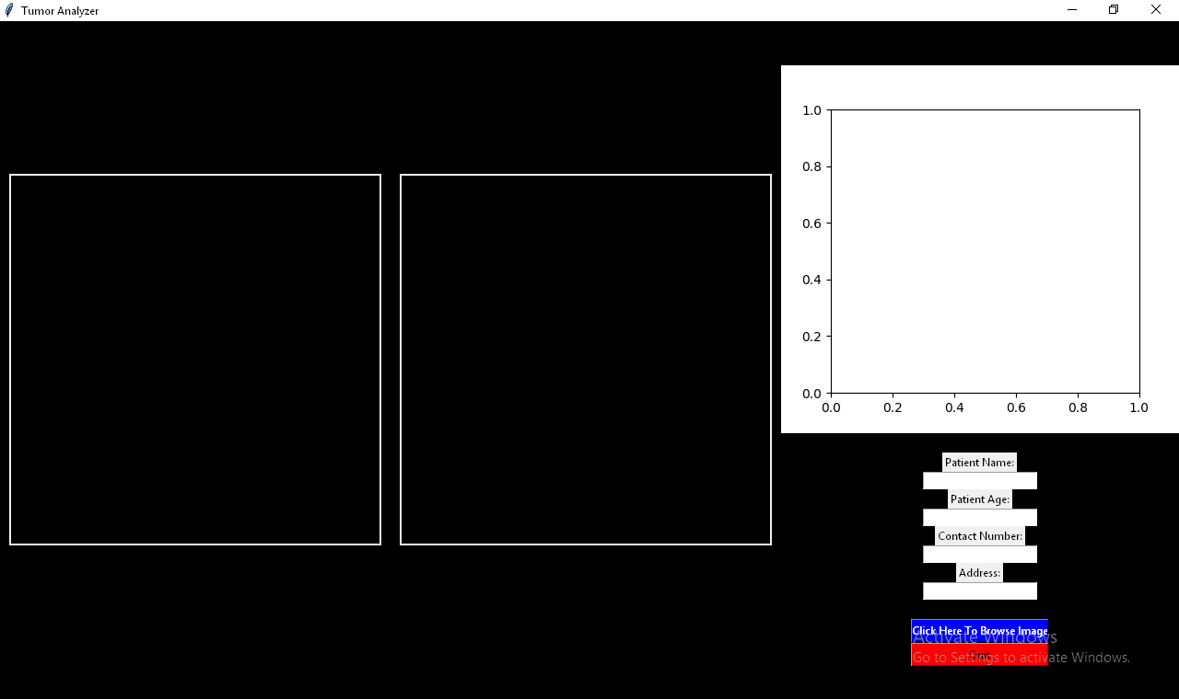

FILLING PATIENT DETAILS

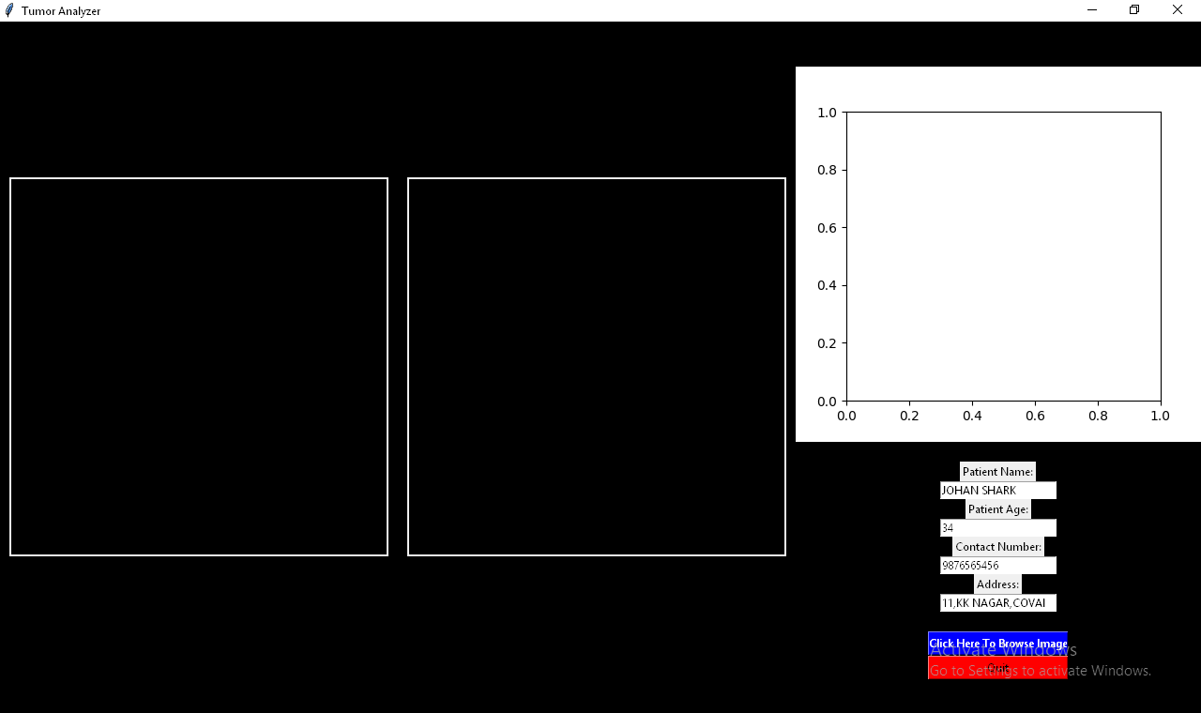

AFTER CLICKING BROWSE BUTTON

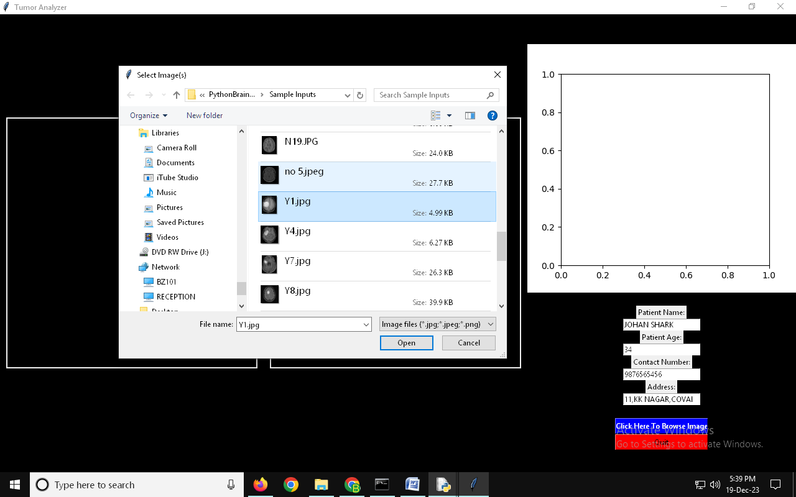

AFTER CHOOSING IMAGE RESULT IS SHOWN (TUMOR PRESENCE IN SIZE)

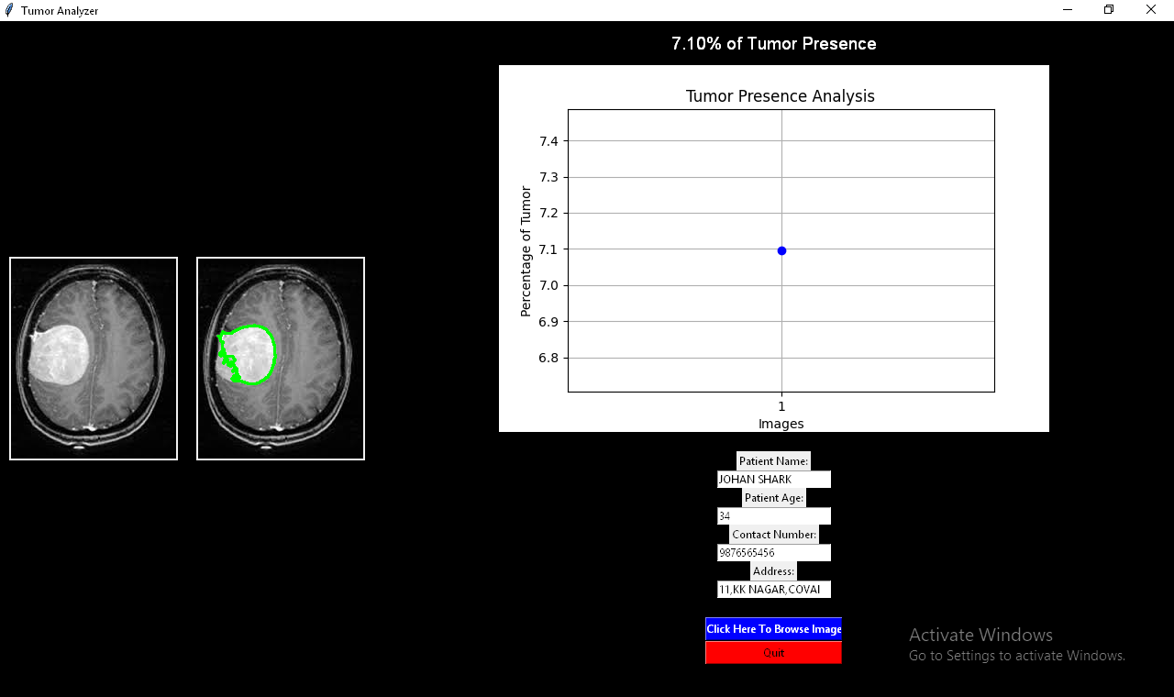

AFTER QUIT YOU CAN SEE THE DOCUMENT NAME WITH PATIENT NAME AND CONTACT

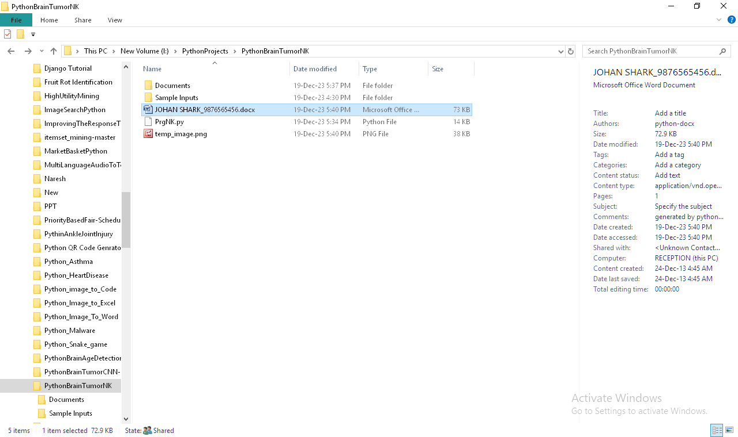

DOCUMENT CONTAINS SCANNED REPORT DETAILS

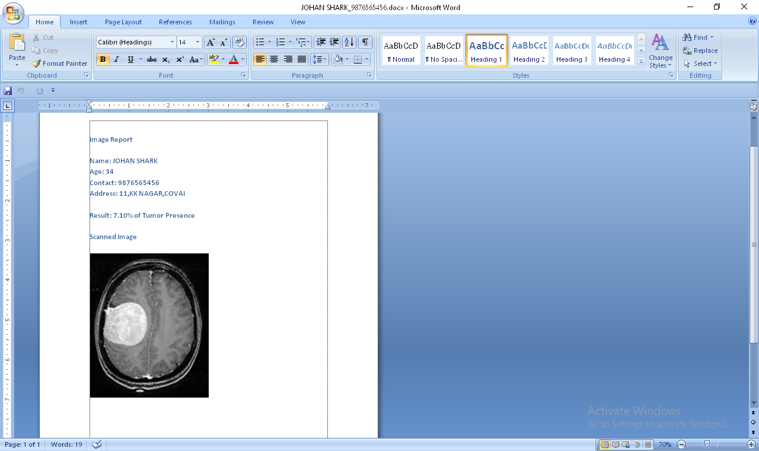

CONCLUSION

In conclusion, the "Brain Tumor Detection with Severity Identification Using K-Means Clustering" project presents a comprehensive and automated solution for the analysis of medical images, particularly brain scans, aimed at early tumor detection and effective treatment planning. Through the integration of OpenCV for image processing, contour detection, percentage calculation, graphical visualization using matplotlib, a user-friendly interface with Tkinter, and report generation with python-docx, the system provides a robust framework for healthcare professionals. By streamlining the identification process and offering quantitative measures of tumor presence, this system enhances the efficiency of medical image analysis. The combination of advanced technologies not only aids in early diagnosis but also facilitates trend analysis and comparison across multiple images, contributing to significant advancements in medical imaging and diagnostics. Ultimately, the project stands as a valuable tool for improving patient care and outcomes in the realm of neurological health.

FUTURE ENHANCEMENTS

Looking towards future enhancements, the "Brain Tumor Detection with Severity Identification Using K-Means Clustering" project could benefit from the integration of machine learning algorithms for more precise tumor classification and severity assessment. Implementing deep learning models, such as convolutional neural networks (CNNs), could enhance the system's ability to distinguish between benign and malignant tumors, providing more accurate diagnostic insights. Additionally, incorporating a larger dataset for training the models would contribute to increased robustness and generalization. Moreover, real-time image processing capabilities and integration with cloud-based storage could be explored to enable seamless collaboration among healthcare professionals and facilitate remote diagnostics. These advancements would not only bolster the system's accuracy and reliability but also position it at the forefront of cutting-edge technologies in the field of medical imaging and tumor detection.

REFERENCES

- Matthew Macdonald, Robert Standefer, “The Complete Reference”, February 21, 2002, PAPERBACK, McGraw-Hill Osborne Media.

- Greg Buczek, “Master the python programming language”, December 13, 2001, PAPERBACK, McGraw-Hill Osborne Media.

- Scott Mitchell, Donny Mack, Stephen Walther, Doug Seven, Bill Anders, “Tips, Tutorials and Code”, August 23, 2001, Book and CD-ROM edition, Sams.

- Danny Ryan, Tommy Ryan, “python image processing”, August 23, 2001, Book and CD-ROM edition, Visual.

- Dave Mercer, “Complete python with neural network”, December 20, 2001, 2nd edition, McGraw-Hill Osborne Media.

WEB REFERENCES

1. http://pythonheaven.com
2. http://www.codeproject.com
3. http://w3schools.com
4. https://www.pythontutor.net
4. python-informations.com/

